INTRODUCTION TO THE EPISTLE TO THE COLOSSIANS

THE CHURCH OF GOD AT COLOSSE WAS ESTABLISHED WHEN THE APOSTLE PAUL WAS ON HIS THIRD MISSIONARY JOURNEY WHEN HE SPENT APPROXIMATELY THREE (3) YEARS IN EPHESUS IN ASIA MINOR.

THE APOSTLE PAUL NEVER VISITED THE CHURCH OF GOD AT COLOSSE BUT ESTABLISHED THE CHURCH OF GOD IN ASIA AT EPHESUS FROM WHICH THE GOSPEL SPREAD INTO THE CITIES OF COLOSSE AND LAODICEA AND HIERAPOLIS WHICH WERE CITIES IN CLOSE PROXIMITY TO EACH OTHER.

THE APOSTLE PAUL WROTE THE EPISTLE TO THE CHURCH OF GOD AT COLOSSE AND THE LETTER TO PHILEMON AT THE SAME TIME IN A.D. 60.

THE EPISTLE TO COLOSSE AND THE LETTER TO PHILEMON RELATE TO EACH OTHER.

THE APOSTLE PAUL SENT WITH THE EPISTLE AND THE LETTER BY THE FOLLOWING FROM PRISON IN ROME WITH BOTH TYCHICUS AND ONESIMUS TOGETHER:

- TYCHICUS CARRIED THE EPISTLE TO THE CHURCH OF GOD
AT COLOSSE WHICH WAS TO BE ALSO READ IN THE CHURCH OF GOD AT LAODICEA.
TYCHICUS ALSO CARRIED THE EPISTLE TO THE CHURCH OF GOD AT EPHESUS.
Eph 6:19-22 (KJV) 19 And ^{G2532} for ^{G5228} me, ^{G1700} that ^{G2443} utterance ^{G3056} may be given ^{G1325} unto me, ^{G3427} that I may open ^{G1722 G457} my ^{G3450} mouth ^{G4750} boldly, ^{G1722 G3954} to make known ^{G1107} the mystery ^{G3466} of the gospel, ^{G2098}
Eph 6:20 (KJV) 20 FOR ^{G5228} WHICH ^{G3739} I AM AN AMBASSADOR ^{G4243} IN ^{G1722} BONDS: ^{G254} that ^{G2443} therein ^{G1722 G846} I may speak boldly, ^{G3955} as ^{G5613} I ^{G3165} ought ^{G1163} to speak. ^{G2980}
Eph 6:21 (KJV) 21 But ^{G1161} that ^{G2443} ye ^{G5210} also ^{G2532} may know ^{G1492} my ^{G1691} affairs, ^{G2596} and how ^{G5101} I do, ^{G4238} TYCHICUS, ^{G5190} A BELOVED ^{G27} BROTHER ^{G80} AND ^{G2532} FAITHFUL ^{G4103} MINISTER ^{G1249} IN ^{G1722} THE LORD, ^{G2962} SHALL MAKE KNOWN ^{G1107} TO YOU ^{G5213} ALL THINGS: ^{G3956}
Eph 6:22 (KJV) 22 Whom ^{G3739} I have sent ^{G3992} unto ^{G4314} you ^{G5209} for ^{G1519} the same ^{G846} purpose, ^{G5124} that ^{G2443} ye might know ^{G1097} our ^{G2257} affairs, ^{G4012} and ^{G2532} that he might comfort ^{G3870} your ^{G5216} hearts. ^{G2588}

Col 4:7-8 (KJV) 7 ALL ^{G3956} MY ^{G1691} STATE ^{G2596} SHALL ^{G1107} TYCHICUS ^{G5190} DECLARE ^{G1107} UNTO YOU, ^{G5213} WHO IS A BELOVED ^{G27} BROTHER, ^{G80} AND ^{G2532} A FAITHFUL ^{G4103} MINISTER ^{G1249} AND ^{G2532} FELLOWSERVANT ^{G4889} IN ^{G1722} THE LORD: ^{G2962}
Col 4:8 (KJV) 8 Whom ^{G3739} I have sent ^{G3992} unto ^{G4314} you ^{G5209} for ^{G1519} the same ^{G846} purpose, ^{G5124} that ^{G2443} he might know ^{G1097} your ^{G5216} estate, ^{G4012} and ^{G2532} comfort ^{G3870} your ^{G5216} hearts; ^{G2588}

- ONESIMUS CARRIED THE LETTER TO PHILEMON
Col 4:7-9 (KJV) 9 WITH ^{G4862} ONESIMUS, ^{G3682} A FAITHFUL ^{G4103} AND ^{G2532} BELOVED ^{G27} BROTHER, ^{G80} who ^{G3739} is ^{G2076} one of ^{G1537} you. ^{G5216} They shall make known ^{G1107} unto you ^{G5213} all things ^{G3956} which ^{G3588} are done here. ^{G5602}

- EPAPHRAS
THE CHURCH WAS NOT ESTALISHED BY PAUL HIMSELF, BUT BY EPAPHRAS A FAITHFUL MINISTER OF CHRIST.
Col 1:7 (KJV) 7 As ^{G2531} ye ^{G3129} also ^{G2532} learned ^{G3129} of ^{G575} EPAPHRAS ^{G1889} our ^{G2257} dear ^{G27} fellowservant, ^{G4889} who ^{G3739} is ^{G2076} for ^{G5228} you ^{G5216} a faithful ^{G4103} minister ^{G1249} of Christ; ^{G5547}

Col 4:12-13 (KJV) 12 EPAPHRAS, ^{G1889} WHO IS ONE OF ^{G1537} YOU, ^{G5216} A SERVANT ^{G1401} OF CHRIST, ^{G5547} saluteth ^{G782} you, ^{G5209} always ^{G3842} labouring fervently ^{G75} for ^{G5228} you ^{G5216} in ^{G1722} prayers, ^{G4335} that ^{G2443} ye may stand ^{G2476} perfect ^{G5046} and ^{G2532} complete ^{G4137} in ^{G1722} all ^{G3956} the will ^{G2307} of God. ^{G2316}
Col 4:13 (KJV) 13 For ^{G1063} I bear ^{G3140} him ^{G846} record, ^{G3140} that ^{G3754} he hath ^{G2192} a great ^{G4183} zeal ^{G2205} for ^{G5228} you, ^{G5216} and ^{G2532} them that are in ^{G1722} Laodicea, ^{G2993} and ^{G2532} them in ^{G1722} Hierapolis. ^{G2404}

Philemon 1:23 (KJV) 23 There salute ^{G782} thee ^{G4571} EPAPHRAS, ^{G1889} MY ^{G3450} FELLOWPRISONER ^{G4869} in ^{G1722} Christ ^{G5547} Jesus; ^{G2424}

- ARCHIPPUS
ARCHIPPUS ALSO EXERCISED A FAITHFUL MINISTRY THERE IN THE CHURCH OF GOD AT COLOSSE.
Col 4:17 (KJV) 17 And ^{G2532} say ^{G2036} to ARCHIPPUS, ^{G751} Take heed ^{G991} to the ministry ^{G1248} which ^{G3739} thou hast received ^{G3880} in ^{G1722} the Lord, ^{G2962} that ^{G2443} thou fulfil ^{G4137} it. ^{G846}

Philemon 1:2 (KJV) 2 And ^{G2532} to our beloved ^{G27} Apphia, ^{G682} and ^{G2532} ARCHIPPUS ^{G751} OUR ^{G2257} FELLOWSOLDIER, ^{G4961} and ^{G2532} to the church ^{G1577} in ^{G2596} thy ^{G4675} house: ^{G3624}

- PHILEMON
PHILEMON WAS ALSO WAS A SLAVE MASTER AND AN ACTIVE MEMBER OF THE CHURCH OF GOD AT COLOSSE.
THE LETTER TO PHILEMON WAS WRITTEN BY THE APOSTLE PAUL TO PHILEMON WHO BELONGED TO THE CHURCH AT COLOSSE ON BEHALF OF HIS RUNAWAY SLAVE ONESIMUS.
Philemon 1:1-25

- ONESIMUS
ONESIMUS WAS A RUNAWAY SLAVE FROM COLOSSE WHO BELONGED TO PHILEMON AND BECAME A DISCIPLE OF JESUS CHRIST WHILE IN PRISON WITH THE APOSTLE PAUL.

- WHEN DID THE APOSTLE PAUL WROTE THIS EPISTLE?
THE APOSTLE PAUL WROTE THIS EPISTLE TO THE CHURCH OF GOD AT COLOSSE WHILE HE WAS IN PRISON IN ROME IN A.D. 59-62 DURING HIS TWO (2) YEARS UNDER HOUSE ARREST IN HIS OWN HIRED HOUSE.
Acts 28:30-31 (KJV) 30 And ^{G1161} Paul ^{G3972} dwelt ^{G3306} two ^{G1333} whole ^{G3650} years ^{G1333} in ^{G1722} his own ^{G2398} hired house, ^{G3410} and ^{G2532} received ^{G588} all ^{G3956} that came in ^{G1531} unto ^{G4314} him, ^{G846}
Acts 28:31 (KJV) 31 Preaching ^{G2784} the kingdom ^{G932} of God, ^{G2316} and ^{G2532} teaching ^{G1321} those things which concern ^{G4012} the Lord ^{G2962} Jesus ^{G2424} Christ, ^{G5547} with ^{G3326} all ^{G3956} confidence, ^{G3954} no man forbidding him. ^{G209}

DURING THE WRITING OF THIS EPISTLE TIMOTHY WAS IN PRISON WITH THE APOSTLE PAUL.
Col 4:3 (KJV) 3 Withal ^{G260} praying ^{G4336} also ^{G2532} for ^{G4012} us, ^{G2257} that ^{G2443} God ^{G2316} would open ^{G455} unto us ^{G2254} a door ^{G2374} of utterance, ^{G3056} to speak ^{G2980} the mystery ^{G3466} of Christ, ^{G5547} for ^{G1223} which ^{G3739} I am ^{G1210} also ^{G2532} IN BONDS: ^{G1210}

Col 4:18 (KJV) 18 The salutation ^{G783} by the hand ^{G5495} of me ^{G1699} Paul. ^{G3972} REMEMBER ^{G3421} MY ^{G3450} BONDS. ^{G1199} Grace ^{G5485} be with ^{G3326} you. ^{G5216} Amen. ^{G281}

TIMOTHY WAS EVENTUALLY RELEASED FROM PRISON BY THE TIME THE APOSTLE PAUL WROTE THE EPISTLE TO THE HEBREWS.
Heb 13:23-24 (KJV) 23 KNOW YE ^{G1097} THAT OUR BROTHER ^{G80} TIMOTHY ^{G5095} IS SET AT LIBERTY; ^{G630} WITH ^{G3326} WHOM, ^{G3739} IF ^{G1437} HE COME ^{G2064} SHORTLY, ^{G5032} I WILL SEE ^{G3700} YOU. ^{G5209}
Heb 13:24 (KJV) 24 Salute ^{G782} all ^{G3956} them that have the rule ^{G2233} over you, ^{G5216} and ^{G2532} all ^{G3956} the saints. ^{G40} They of ^{G575} Italy ^{G2482} salute ^{G782} you. ^{G5209}

- WHAT WERE SOME OF THE ISSUES AT THE CHURCH OF LAODICEA IN WHICH THE APOSTLE PAUL MAY HAVE WRITTEN TO THE CHURCH OF GOD AT LAODICEA?
THERE IS NO EVIDENCE OF AN EPISTLE TO THE CHURCH OF GOD AT LAODICEA, HOWEVER IN THE BOOK OF REVELATION WE SEE JESUS CHRIST CORRECTING THE CHURCH OF GOD LAODICEA AS BEING LUKEWARM AND IN A BAD SPIRITUAL STATE.

THE EPISTLE WRITTEN BY THE APOSTLE PAUL TO THE CHURCH OF GOD AT COLOSSE WAS TO BE READ IN THE CHURCH OF GOD AT LAODICEA.
Col 4:16-18 (KJV) 16 And ^{G2532} when ^{G3752} this epistle ^{G1992} is read ^{G314} among ^{G3844} you, ^{G5213} cause ^{G4160} that ^{G2443} it be read ^{G314} also ^{G2532} in ^{G1722} the church ^{G1577} of the Laodiceans; ^{G2994} and ^{G2532} that ^{G2443} ye ^{G5210} likewise ^{G2532} read ^{G314} the epistle from ^{G1537} Laodicea. ^{G2993}

Col 4:17 (KJV) 17 And ^{G2532} say ^{G2036} to Archippus, ^{G751} Take heed ^{G991} to the ministry ^{G1248} which ^{G3739} thou hast received ^{G3880} in ^{G1722} the Lord, ^{G2962} that ^{G2443} thou fulfil ^{G4137} it. ^{G846}
THE APOSTLE PAUL WAS IN PRISON WHEN HE WROTE THE EPISTLE TO THE CHURCHES OF GOD IN COLOSSE AND LAODICEA.
Col 4:18 (KJV) 18 The salutation ^{G783} by the hand ^{G5495} of me ^{G1699} Paul. ^{G3972} REMEMBER ^{G3421} MY ^{G3450} BONDS. ^{G1199} Grace ^{G5485} be with ^{G3326} you. ^{G5216} Amen. ^{G281}

WE SEE JESUS CHRIST CORRECTION TO THE CHURCH OF GOD AT LAODICEA WHICH WOULD HAVE HIGHLIGHTED SOME OF THE ISSUES THE APOSTLE PAUL WOULD HAVE ADDRESSED IN HIS EPISTLE BY THE HOLY SPIRIT.
THE CHURCH OF GOD AT LAODICEA WOULD HAVE DEGENERATED INTO SPIRITUALLY WRETCHED AND BLIND STATE AND WHICH NEEDED TO BE ADDRESSED BEFORE ALL WAS SPIRITUALLY LOST.
Rev 3:14-22 (KJV) 14 And ^{G2532} unto the angel ^{G32} of THE CHURCH ^{G1577} OF THE LAODICEANS ^{G2994} WRITE; ^{G1125} These things ^{G3592} saith ^{G3004} the Amen, ^{G281} the faithful ^{G4103} and ^{G2532} true ^{G228} witness, ^{G3144} the beginning ^{G746} of the creation ^{G2937} of God; ^{G2316}
Rev 3:15 (KJV) 15 I know ^{G1492} thy ^{G4675} works, ^{G2041} that ^{G3754} thou art ^{G1488} neither ^{G3777} cold ^{G5593} nor ^{G3777} hot: ^{G2200} I would ^{G3785} thou wert ^{G1498} cold ^{G5593} or ^{G2228} hot. ^{G2200}
Rev 3:16 (KJV) 16 So ^{G3779} then because ^{G3754} thou art ^{G1488} lukewarm, ^{G5513} and ^{G2532} NEITHER ^{G3777} COLD ^{G5593} NOR ^{G3777} HOT, ^{G2200} I WILL ^{G3195} SPUE ^{G1692} THEE ^{G4571} OUT OF ^{G1537} MY ^{G3450} MOUTH. ^{G4750}
Rev 3:17 (KJV) 17 Because ^{G3754} thou sayest, ^{G3004 G3754} I am ^{G1510} rich, ^{G4145} and ^{G2532} increased with goods, ^{G4147} and ^{G2532} have ^{G2192} need ^{G5532} of nothing; ^{G3762} AND ^{G2532} KNOWEST ^{G1492} NOT ^{G3756} THAT ^{G3754} THOU ^{G4771} ART ^{G1488} WRETCHED, ^{G5005} AND ^{G2532} MISERABLE, ^{G1652} AND ^{G2532} POOR, ^{G4434} AND ^{G2532} BLIND, ^{G5185} AND ^{G2532} NAKED: ^{G1131}
Rev 3:18 (KJV) 18 I counsel ^{G4823} thee ^{G4671} to buy ^{G59} of ^{G3844} me ^{G1700} gold ^{G5553} tried ^{G4448} in ^{G1537} the fire, ^{G4442} that ^{G2443} thou mayest be rich; ^{G4147} and ^{G2532} white ^{G3022} raiment, ^{G2440} that ^{G2443} thou mayest be clothed, ^{G4016} and ^{G2532} that the shame ^{G152} of thy ^{G4675} nakedness ^{G1132} do ^{G5319} not ^{G3361} appear; ^{G5319} and ^{G2532} anoint ^{G1472} thine ^{G4675} eyes ^{G3788} with eyesalve, ^{G2854} that ^{G2443} thou mayest see. ^{G991}
Rev 3:19 (KJV) 19 As many as ^{G3745 G1437} I love, ^{G5368} I ^{G1473} rebuke ^{G1651} and ^{G2532} chasten: ^{G3811} be zealous ^{G2206} therefore, ^{G3767} and ^{G2532} repent. ^{G3340}
Rev 3:20 (KJV) 20 Behold, ^{G2400} I stand ^{G2476} at ^{G1909} the door, ^{G2374} and ^{G2532} knock: ^{G2925} if ^{G1437} any man ^{G5100} hear ^{G191} my ^{G3450} voice, ^{G5456} and ^{G2532} open ^{G455} the door, ^{G2374} I will come in ^{G1525} to ^{G4314} him, ^{G846} and ^{G2532} will sup ^{G1172} with ^{G3326} him, ^{G846} and ^{G2532} he ^{G846} with ^{G3326} me. ^{G1700}
Rev 3:21 (KJV) 21 To him ^{G846} that overcometh ^{G3528} will I grant ^{G1325} to sit ^{G2523} with ^{G3326} me ^{G1700} in ^{G1722} my ^{G3450} throne, ^{G2362} even ^{G2504} as ^{G5613} I also ^{G2504} overcame, ^{G3528} and ^{G2532} am set down ^{G2523} with ^{G3326} my ^{G3450} Father ^{G3962} in ^{G1722} his ^{G846} throne. ^{G2362}
Rev 3:22 (KJV) 22 He that hath ^{G2192} an ear, ^{G3775} let him hear ^{G191} what ^{G5101} the Spirit ^{G4151} saith ^{G3004} unto the churches. ^{G1577}

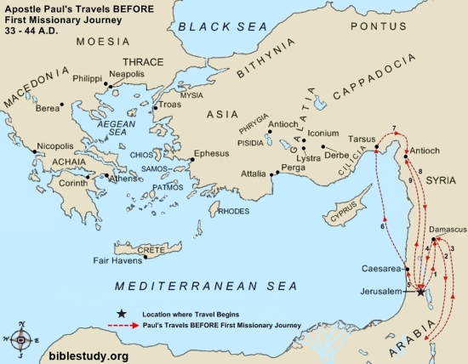
THE APOSTLE PAUL’S JOURNEYS BEFORE HIS THREE (3) MISSIONARY JOURNEYS.

THE APOSTLE PAUL FIRST MISSIONARY JOURNEY
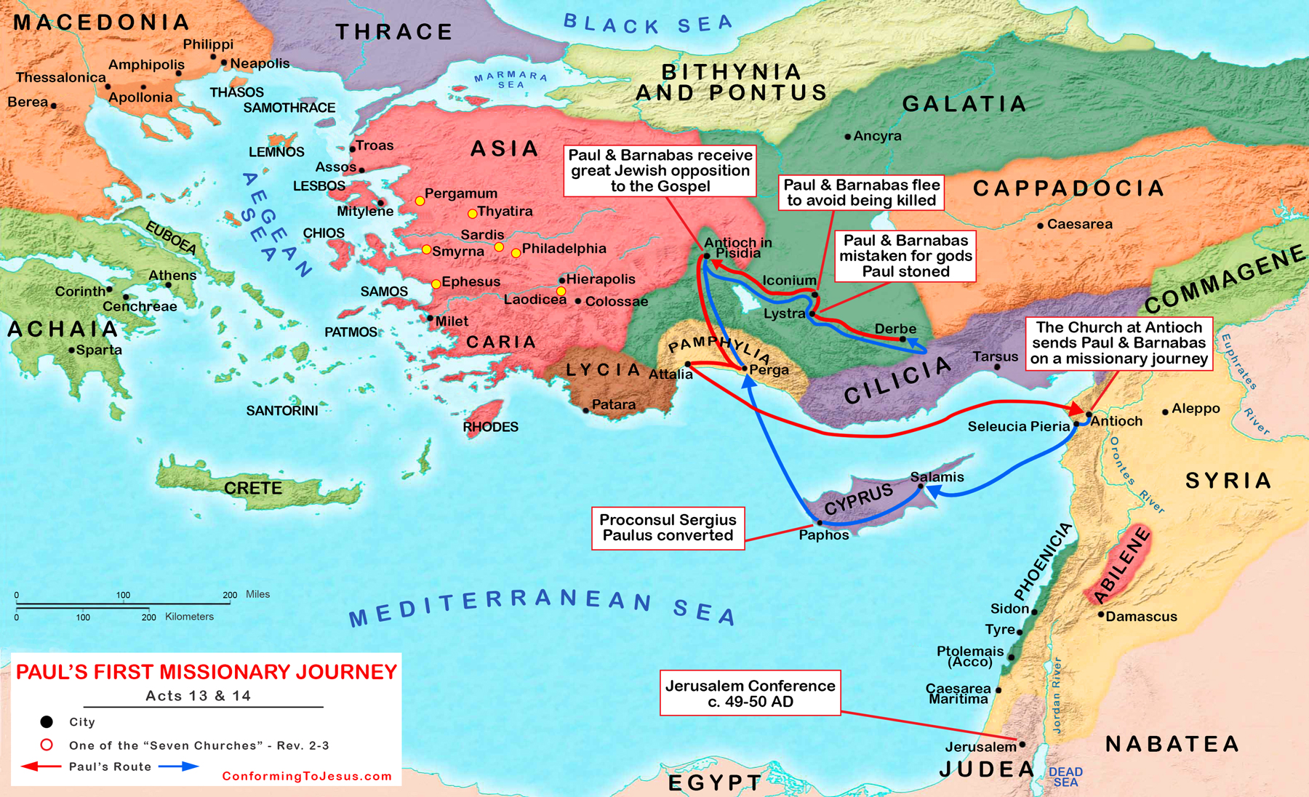

THE APOSTLE PAUL SECOND MISSIONARY JOURNEY
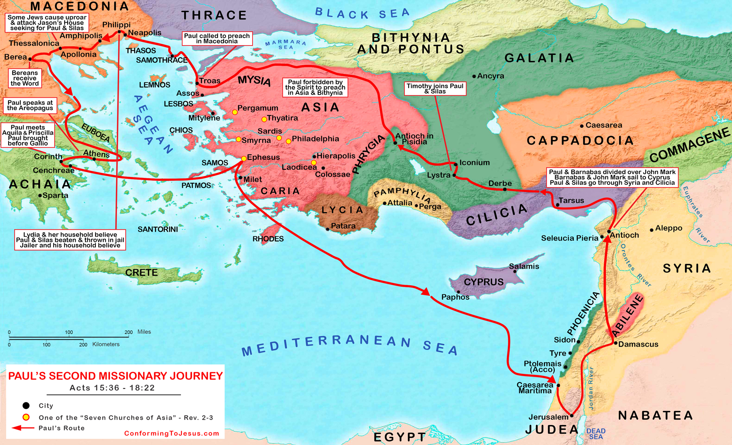

THE APOSTLE PAUL THIRD MISSIONARY JOURNEY
