INTRODUCTION TO THE EPISTLE TO THE PHILIPPIANS

Introduction
THE CHURCH OF GOD AT PHILIPPI WAS THE CHIEF CITY LOCATED IN THE PROVINCE OF MACEDONIA.
THE APOSTLE PAUL ESTABLISHED THE CHURCH OF GOD AT PHILIPPI ON HIS SECOND MISSIONARY JOURNEY.
HE ALSO VISTED AND SPENT A WHILE AT THE CHURCH OF PHILIPPI ON HIS THIRD MISSIONARY JOURNEY.

- THE CHURCH OF GOD AT PHILIPPI IN MACEDONIA
ESTABLISHED BY THE APOSTLE PAUL DURING HIS SECOND MISSIONARY JOURNEY.
Acts 16:12-40 (KJV) 12 AND ^{G5037} FROM THENCE ^{G1564} TO ^{G1519} PHILIPPI, ^{G5375} WHICH ^{G3748} IS ^{G2076} THE CHIEF ^{G4413} CITY ^{G4172} OF THAT PART ^{G3310} OF MACEDONIA, ^{G3109} AND A COLONY: ^{G2862} and ^{G1161} we were ^{G2258} in ^{G1722} that ^{G5026} city ^{G4172} abiding ^{G1304} certain ^{G5100} days.
Acts 16:13 (KJV) 13 And ^{G5037} on the sabbath ^{G4521 G2250} we went ^{G1831} out of ^{G1854} the city ^{G4172} by ^{G3844} a river side, ^{G4215} where ^{G3757} prayer ^{G4335} was wont ^{G3543} to be made; ^{G1511} and ^{G2532} we sat down, ^{G2523} and spake ^{G2980} unto the women ^{G1135} which resorted ^{G4905} thither.
Acts 16:14 (KJV) 14 And ^{G2532} a certain ^{G5100} woman ^{G1135} named ^{G3686} Lydia, ^{G3070} a seller of purple, ^{G4211} of the city ^{G4172} of Thyatira, ^{G2363} which worshipped ^{G4576} God, ^{G2316} heard ^{G191} us: whose ^{G3739} heart ^{G2588} the Lord ^{G2962} opened, ^{G1272} that she attended ^{G4337} unto the things which were spoken ^{G2980} of ^{G5259} Paul. ^{G3972}
Acts 16:15 (KJV) 15 And ^{G1161} when ^{G5613} she was baptized, ^{G907} and ^{G2532} her ^{G846} household, ^{G3624} she besought ^{G3870} us, saying, ^{G3004} If ^{G1487} ye have judged ^{G2919} me ^{G3165} to be ^{G1511} faithful ^{G4103} to the Lord, ^{G2962} come ^{G1525} into ^{G1519} my ^{G3450} house, ^{G3624} and abide ^{G3306} there. And ^{G2532} she constrained ^{G3849} us. ^{G2248}
Acts 16:16 (KJV) 16 And ^{G1161} it came to pass, ^{G1096} as we ^{G2257} went ^{G4198} to ^{G1519} prayer, ^{G4335} a certain ^{G5100} damsel ^{G3814} possessed ^{G2192} with a spirit ^{G4151} of divination ^{G4436} met ^{G528} us, ^{G2254} which ^{G3748} brought ^{G3930} her ^{G846} masters ^{G2962} much ^{G4183} gain ^{G2039} by soothsaying: ^{G3132}
Acts 16:17 (KJV) 17 The same ^{G3778} followed ^{G2628} Paul ^{G3972} and ^{G2532} us, ^{G2254} and cried, ^{G2896} saying, ^{G3004} These ^{G3778} men ^{G444} are ^{G1526} the servants ^{G1401} of the most high ^{G5310} God, ^{G2316} which ^{G3748} shew ^{G2605} unto us ^{G2254} the way ^{G3598} of salvation. ^{G4991}
Acts 16:18 (KJV) 18 And ^{G1161} this ^{G5124} did she ^{G4160 G1909} many ^{G4183} days. ^{G2250} But ^{G1161} Paul, ^{G3972} being grieved, ^{G1278} turned ^{G1994} and ^{G2532} said ^{G2036} to the spirit, ^{G4151} I command ^{G3853} thee ^{G4671} in ^{G1722} the name ^{G3686} of Jesus ^{G2424} Christ ^{G5547} to come ^{G1831} out of ^{G575} her. ^{G846} And ^{G2532} he came out ^{G1831} the same ^{G846} hour. ^{G5610}
Acts 16:19 (KJV) 19 And ^{G1161} when her ^{G846} masters ^{G2962} saw ^{G1492} that ^{G3754} the hope ^{G1680} of their ^{G846} gains ^{G2039} was gone, ^{G1831} they caught ^{G1949} Paul ^{G3972} and ^{G2532} Silas, ^{G4609} and drew ^{G1670} them into ^{G1519} the marketplace ^{G58} unto ^{G1909} the rulers, ^{G758}
Acts 16:20 (KJV) 20 And ^{G2532} brought ^{G4317} them ^{G846} to the magistrates, ^{G4755} saying, ^{G2036} These ^{G3778} men, ^{G444} being ^{G5225} Jews, ^{G2453} do exceedingly trouble ^{G1613} our ^{G2257} city, ^{G4172}
Acts 16:21 (KJV) 21 And ^{G2532} teach ^{G2605} customs, ^{G1485} which ^{G3739} are ^{G1832 ➔} not ^{G3756} lawful ^{G1832} for us ^{G2254} to receive, ^{G3858} neither ^{G3761} to observe, ^{G4160} being ^{G5607} Romans. ^{G4514}
Acts 16:22 (KJV) 22 And ^{G2532} the multitude ^{G3793} rose up together ^{G4911} against ^{G2596} them: ^{G846} and ^{G2532} the magistrates ^{G4755} rent off ^{G4048} their ^{G846} clothes, ^{G2440} and commanded ^{G2753} to beat ^{G4463} them.
Acts 16:23 (KJV) 23 And ^{G5037} when they had laid ^{G2007} many ^{G4183} stripes ^{G4127} upon them, ^{G846} they cast ^{G906} them into ^{G1519} prison, ^{G5438} charging ^{G3853} the jailor ^{G1200} to keep ^{G5083} them ^{G846} safely: ^{G806}
Acts 16:24 (KJV) 24 Who, ^{G3739} having received ^{G2983} such ^{G5108} a charge, ^{G3852} thrust ^{G906} them ^{G846} into ^{G1519} the inner ^{G2082} prison, ^{G5438} and ^{G2532} made ^{G805} their ^{G846} feet ^{G4228} fast ^{G805} in ^{G1519} the stocks. ^{G3586}
Acts 16:25 (KJV) 25 And ^{G1161} at ^{G2596} midnight ^{G3317} Paul ^{G3972} and ^{G2532} Silas ^{G4609} prayed, ^{G4336} and sang praises ^{G5214} unto God: ^{G2316} and ^{G1161} the prisoners ^{G1198} heard ^{G1874} them. ^{G846}
Acts 16:26 (KJV) 26 And ^{G1161} suddenly ^{G869} there was ^{G1096} a great ^{G3173} earthquake, ^{G4578} so that ^{G5620} the foundations ^{G2310} of the prison ^{G1201} were shaken: ^{G4531} and ^{G5037} immediately ^{G3916} all ^{G3956} the doors ^{G2374} were opened, ^{G455} and ^{G2532} every one's ^{G3956} bands ^{G1199} were loosed. ^{G447}
Acts 16:27 (KJV) 27 And ^{G1161} the keeper of the prison ^{G1200} awaking ^{G1096} out of his sleep, ^{G1853} and ^{G2532} seeing ^{G1492} the prison ^{G5438} doors ^{G2374} open, ^{G455} he drew out ^{G4685} his sword, ^{G3162} and would ^{G3195} have killed ^{G337} himself, ^{G1438} supposing ^{G3543} that the prisoners ^{G1198} had been fled. ^{G1628}
Acts 16:28 (KJV) 28 But ^{G1161} Paul ^{G3972} cried ^{G5455} with a loud ^{G3173} voice, ^{G5456} saying, ^{G3004} Do ^{G4238} thyself ^{G4572} no ^{G3367} harm: ^{G2556} for ^{G1063} we are ^{G2070} all ^{G537} here. ^{G1759}
Acts 16:29 (KJV) 29 Then ^{G1161} he called ^{G154} for a light, ^{G5457} and sprang in, ^{G1530} and ^{G2532} came ^{G1096} trembling, ^{G1790} and fell down before ^{G4363} Paul ^{G3972} and ^{G2532} Silas, ^{G4609}
Acts 16:30 (KJV) 30 And ^{G2532} brought ^{G4254} them ^{G846} out, ^{G1854} and said, ^{G5346} Sirs, ^{G2962} what ^{G5101} must ^{G1163} I ^{G3165} do ^{G4160} to ^{G2443} be saved? ^{G4982}
Acts 16:31 (KJV) 31 And ^{G1161} they said, ^{G2036} Believe ^{G4100} on ^{G1909} the Lord ^{G2962} Jesus ^{G2424} Christ, ^{G5547} and ^{G2532} thou ^{G4771} shalt be saved, ^{G4982} and ^{G2532} thy ^{G4675} house. ^{G3624}
Acts 16:32 (KJV) 32 And ^{G2532} they spake ^{G2980} unto him ^{G846} the word ^{G3056} of the Lord, ^{G2962} and ^{G2532} to all ^{G3956} that were in ^{G1722} his ^{G846} house. ^{G3614}
Acts 16:33 (KJV) 33 And ^{G2532} he took ^{G3880} them ^{G846 G1722} the same ^{G1565} hour ^{G5610} of the night, ^{G3571} and washed ^{G3068} their stripes; ^{G575 G4127} and ^{G2532} was baptized, ^{G907} he ^{G846} and ^{G2532} all ^{G3956} his, ^{G846} straightway. ^{G3916}
Acts 16:34 (KJV) 34 And ^{G5037} when he had brought ^{G321} them ^{G846} into ^{G1519} his house, ^{G3624} he set ^{G3908 ➔} meat ^{G5132} before them, ^{G3908} and ^{G2532} rejoiced, ^{G21} believing ^{G4100} in God ^{G2316} with all ^{G3832} his ^{G846} house. ^{G3832}
Acts 16:35 (KJV) 35 And ^{G1161} when it was ^{G1096} day, ^{G2250} the magistrates ^{G4755} sent ^{G649} the serjeants, ^{G4465} saying, ^{G3004} Let ^{G630} those ^{G1565} men ^{G444} go. ^{G630}
Acts 16:36 (KJV) 36 And ^{G1161} the keeper of the prison ^{G1200} told ^{G518} this ^{G5128} saying ^{G3056} to ^{G4314} Paul, ^{G3972 G3754} The magistrates ^{G4755} have sent ^{G649} to ^{G2443} let you go: ^{G630} now ^{G3568} therefore ^{G3767} depart, ^{G1831} and go ^{G4198} in ^{G1722} peace. ^{G1515}
Acts 16:37 (KJV) 37 But ^{G1161} Paul ^{G3972} said ^{G5346} unto ^{G4314} them, ^{G846} They have beaten ^{G1194} us ^{G2248} openly ^{G1219} uncondemned, ^{G178} being ^{G5225} Romans, ^{G4514 G444} and have cast ^{G906} us into ^{G1519} prison; ^{G5438} and ^{G2532} now ^{G3568} do they thrust ^{G1544} us ^{G2248} out ^{G1544} privily? ^{G2977} nay ^{G3756} verily; ^{G1063} but ^{G235} let them come ^{G2064} themselves ^{G846} and fetch ^{G1806} us ^{G2248} out.
Acts 16:38 (KJV) 38 And ^{G1161} the serjeants ^{G4465} told ^{G312} these ^{G5023} words ^{G4487} unto the magistrates: ^{G4755} and ^{G2532} they feared, ^{G5399} when they heard ^{G191} that ^{G3754} they were ^{G1526} Romans.
Acts 16:39 (KJV) 39 And ^{G2532} they came ^{G2064} and besought ^{G3870} them, ^{G846} and ^{G2532} brought them out, ^{G1806} and desired ^{G2065} them to depart out ^{G1831} of the city.
Acts 16:40 (KJV) 40 And ^{G1161} they went ^{G1831} out of ^{G1537} the prison, ^{G5438} and entered ^{G1525} into ^{G1519} the house of Lydia: ^{G3070} and ^{G2532} when they had seen ^{G1492} the brethren, ^{G80} they comforted ^{G3870} them, ^{G846} and ^{G2532} departed.

- THE CHURCH OF GOD AT PHILIPPI IN MACEDONIA
VISTED BY THE APOSTLE PAUL DURING HIS THIRD MISSIONARY JOURNEY.
THE APOSTLE PAUL VISITED THE CHURCH OF GOD AT PHILIPPI ONCE AGAIN ON HIS THIRD MISSIONARY JOURNEY AND SPENT THE FEASTS OF THE PASSOVER AND DAYS OF UNLEAVENED BREAD AT PHILIPPI BEFORE JOURNEYING TO JERUSALEM TO KEEP PENTECOST.
Acts 20:1-3 (KJV) 1 And ^{G1161} after ^{G3326} the uproar ^{G2351} was ceased, ^{G3973} Paul ^{G3972} called ^{G4341} unto him the disciples, ^{G3101} and ^{G2532} embraced ^{G782} them, AND DEPARTED ^{G1831} FOR TO GO ^{G4198} INTO ^{G1519} MACEDONIA.
Acts 20:2 (KJV) 2 AND ^{G1161} WHEN HE HAD GONE OVER ^{G1330} THOSE ^{G1565} PARTS, ^{G3313} AND ^{G2532} HAD GIVEN ^{G4183} THEM ^{G846} MUCH ^{G4183} EXHORTATION, ^{G3870 G3056} he came ^{G2064} into ^{G1519} Greece,
Acts 20:3 (KJV) 3 And ^{G5037} there abode ^{G4160} three ^{G5140} months. ^{G3376} And when the Jews ^{G5259 G2453} laid ^{G1096} wait ^{G1917} for him, ^{G846} as he was about ^{G3195} to sail ^{G321} into ^{G1519} Syria, ^{G4947} HE PURPOSED ^{G1096 G1106} TO RETURN ^{G5290} THROUGH ^{G1223} MACEDONIA.
Acts 20:4 (KJV) 4 And ^{G1161} there accompanied ^{G4902} him ^{G846} into ^{G891} Asia ^{G773} Sopater ^{G4986} of Berea; ^{G961} and ^{G1161} of the Thessalonians, ^{G2331} Aristarchus ^{G708} and ^{G2532} Secundus; ^{G4580} and ^{G2532} Gaius ^{G1050} of Derbe, ^{G1190} and ^{G2532} Timotheus; ^{G5095} and ^{G1161} of Asia, ^{G774} Tychicus ^{G5190} and ^{G2532} Trophimus.
Acts 20:5 (KJV) 5 These ^{G3778} going before ^{G4281} tarried ^{G3306} for us ^{G2248} at ^{G1722} Troas.
Acts 20:6 (KJV) 6 AND ^{G1161} WE ^{G2249} SAILED AWAY ^{G1602} FROM ^{G575} PHILIPPI ^{G5375} AFTER ^{G3326} THE DAYS ^{G2250} OF UNLEAVENED BREAD, ^{G106} and ^{G2532} came ^{G2064} unto ^{G4314} them ^{G846} to ^{G1519} Troas ^{G5174} in ^{G891} five ^{G4002} days; ^{G2250} where ^{G3757} we abode ^{G1304} seven ^{G2033} days.

- WHEN DID THE APOSTLE PAUL WROTE THIS EPISTLE?
THE APOSTLE PAUL WROTE THIS EPISTLE TO THE CHURCH OF GOD AT PHILIPPI WHILE HE WAS IN PRISON IN ROME ITALY IN A.D. 59-62 DURING HIS TWO (2) YEARS UNDER HOUSE ARREST IN HIS OWN HIRED HOUSE.
Acts 28:30-31 (KJV) 30 And ^{G1161} Paul ^{G3972} dwelt ^{G3306} two ^{G1333} whole ^{G3650} years ^{G1333} in ^{G1722} his own ^{G2398} hired house, ^{G3410} and ^{G2532} received ^{G588} all ^{G3956} that came in ^{G1531} unto ^{G4314} him, ^{G846}
Acts 28:31 (KJV) 31 Preaching ^{G2784} the kingdom ^{G932} of God, ^{G2316} and ^{G2532} teaching ^{G1321} those things which concern ^{G4012} the Lord ^{G2962} Jesus ^{G2424} Christ, ^{G5547} with ^{G3326} all ^{G3956} confidence, ^{G3954} no man forbidding him. ^{G209}

Phil 1:13 (KJV) 13 SO THAT ^{G5620} MY ^{G3450} BONDS ^{G1199} IN ^{G1722} CHRIST ^{G5547} ARE ^{G1096} MANIFEST ^{G5318} IN ^{G1722} ALL ^{G3650} THE PALACE, ^{G4232} and ^{G2532} in all ^{G3956} other ^{G3062} places;

Phil 4:22 (KJV) 22 All ^{G3956} the saints ^{G40} salute ^{G782} you, ^{G5209 G1161} chiefly ^{G3122} they that are of ^{G1537} CAESAR'S ^{G2541} HOUSEHOLD. ^{G3614}

DURING THE WRITING OF THIS EPISTLE TIMOTHY WAS IN PRISON WITH THE APOSTLE PAUL.
Phil 1:1 (KJV) 1 PAUL ^{G3972} AND ^{G2532} TIMOTHEUS, ^{G5095} the servants ^{G1401} of Jesus ^{G2424} Christ, ^{G5547} to all ^{G3956} the saints ^{G40} in ^{G1722} Christ ^{G5547} Jesus ^{G2424} which are ^{G5607} at ^{G1722} Philippi, ^{G5375} with ^{G4862} the bishops ^{G1985} and ^{G2532} deacons: ^{G1249}

TIMOTHY WAS EVENTUALLY RELEASED FROM PRISON BY THE TIME THE APOSTLE PAUL WROTE THE EPISTLE TO THE HEBREWS.
Heb 13:23-24 (KJV) 23 KNOW YE ^{G1097} THAT OUR BROTHER ^{G80} TIMOTHY ^{G5095} IS SET AT LIBERTY; ^{G630} WITH ^{G3326} WHOM, ^{G3739} IF ^{G1437} HE COME ^{G2064} SHORTLY, ^{G5032} I WILL SEE ^{G3700} YOU. ^{G5209}
Heb 13:24 (KJV) 24 Salute ^{G782} all ^{G3956} them that have the rule ^{G2233} over you, ^{G5216} and ^{G2532} all ^{G3956} the saints. ^{G40} They of ^{G575} Italy ^{G2482} salute ^{G782} you. ^{G5209}
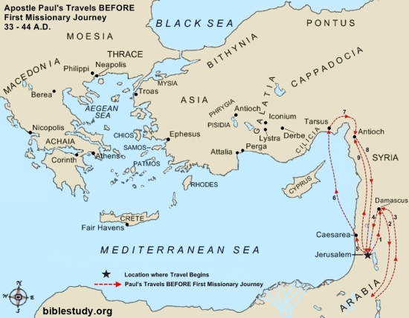
THE APOSTLE PAUL’S JOURNEYS BEFORE HIS THREE (3) MISSIONARY JOURNEYS.

THE APOSTLE PAUL FIRST MISSIONARY JOURNEY
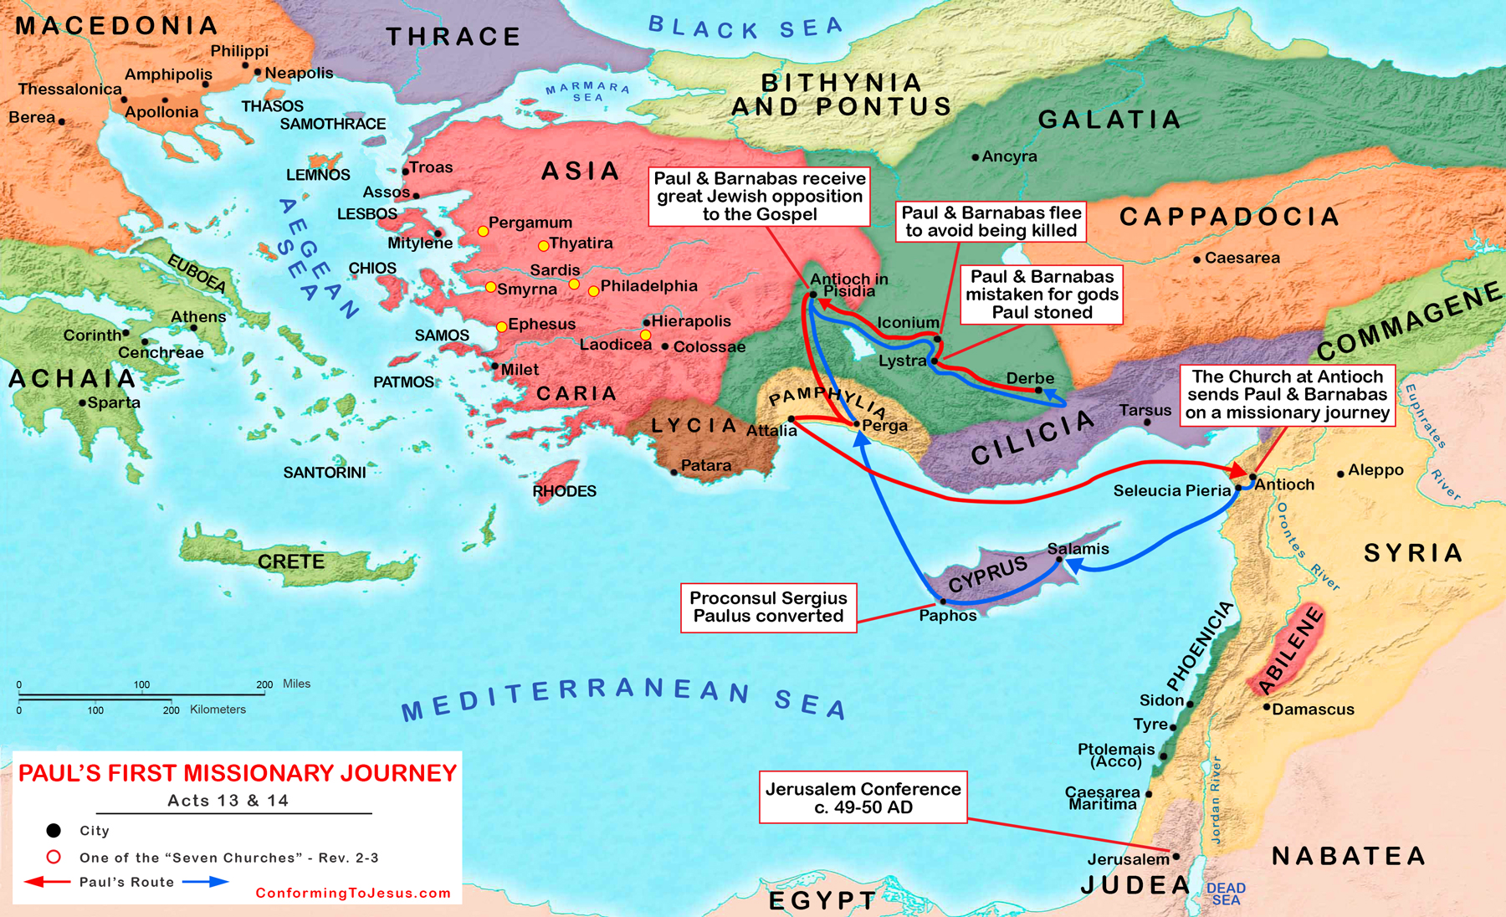

THE APOSTLE PAUL SECOND MISSIONARY JOURNEY
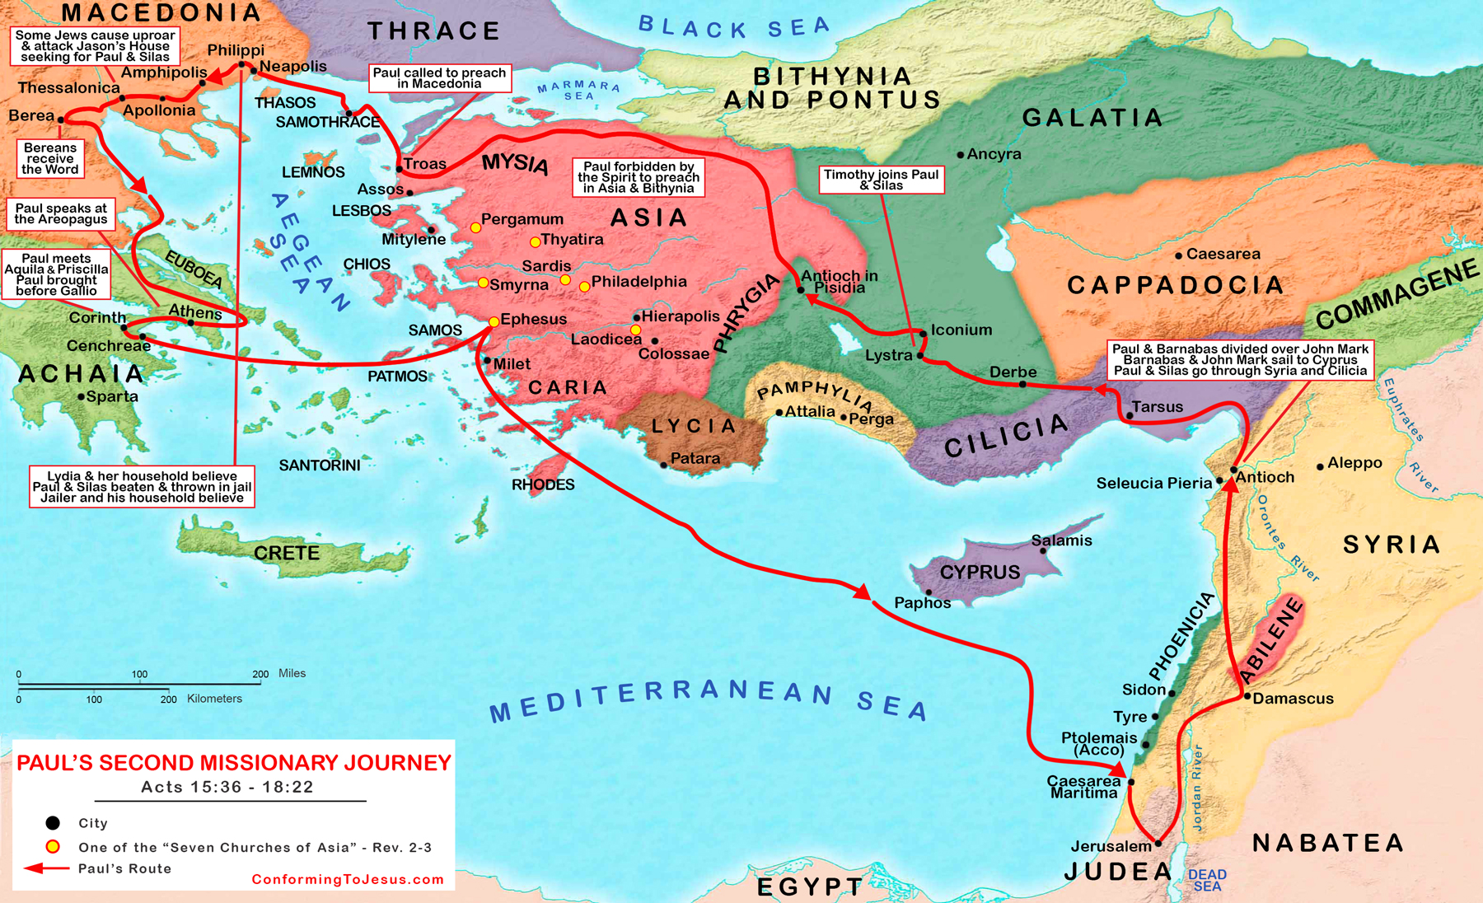

THE APOSTLE PAUL THIRD MISSIONARY JOURNEY
