THE EPISTLE TO TITUS

INTRODUCTION

SEE MAPS ATTACHED FOR THE LOCATION OF NICOPOLIS IN MACEDONIA.

THE APOSTLE PAUL WROTE THE EPISTLE TO TITUS FROM CITY OF NICOPOLIS BY THE SEA IN MACEDONIA ON HIS SECOND MISSIONARY JOURNEY AFTER BRETHREN SENT HIM AWAY BECAUSE OF THE PERSECUTION AT THESSALONICA AND THEN AT BEREA BY THE JEWS THESSALONICA.

IN TITUS CHAPTER 3 WE SEE THE EVIDENCE OF THE LOCATION FROM WHERE THE APOSTLE PAUL WROTE THE EPISTLE TO TITUS, WHICH WAS AT NICOPOLIS IN MACEDONIA DURING HIS SECOND MISSIONARY JOURNEY.
Titus 3:12 (KJV) 12 When ^{G3752} I shall send ^{G3992} Artemas ^{G734} unto ^{G4314} thee, ^{G4571} or ^{G2228} Tychicus, ^{G5190} be diligent ^{G4704} to come ^{G2064} unto ^{G4314} me ^{G3165} to ^{G1519} NICOPOLIS: ^{G3533} for ^{G1063} I have determined ^{G2919} there ^{G1563} to winter. ^{G3914}
OTHER RELATED SCRIPTURES AS TO THE EVIDENCE TO WHERE THE APOSTLE PAUL LOCATION WAS WHEN HE WROTE THE EPISTLE TO TITUS.
DURING THE APOSTLE PAUL SECOND MISSIONARY JOURNEY HE WAS PERSECUTED BY THE JEWS OF THE CITY OF THESSALONICA IN MACEDONIA AND WAS SENT BY THE BRETHREN TO THE CITY OF BEREA STILL IN MACEDONIA.
WHEN THE JEWS OF THESSALONICA, HEARD THAT PAUL WAS AT BEREA THEY CAME TO BEREA TO PERSECUTE PAUL ALSO AND THE BRETHREN SENT PAUL AWAY “TO GO AS IT WERE TO THE SEA” WHICH WAS TO THE COMMERCIAL CITY OF NICOLPOLIS ON THE SEA COAST, BEFORE SENDING HIM TO ATHENS.

MANY SCHOLARS HAVE CONCLUDED ON MAPS THAT THE APOSTLE PAUL JOURNEYED TO ATHENS VIA SEA THINKING THAT THE STATEMENT “TO GO AS IT WERE TO THE SEA” BY LUKE THE PHYSICIAN, WHO WROTE THE BOOK OF ACTS, MEANT THAT FROM BEREA THE APOSTLE PAUL JOURNEYED TO ATHEN VIA THE SEA, WHICH IS NOT THE CASE.
FROM BEAREA ONE CAN JOURNEY TO ATHENS VIA LAND, WHICH WAS THE CASE.

IT WAS IN THE CITY OF NICOPOLIS THAT THE APOSTLE PAUL WROTE THE EPISTLE TO TITUS AS HE WAS DETERMINED TO SPEND WINTER AT NICOPOLIS.
WHEN THE APOSTLE PAUL WAS ON HIS SECOND MISSIONARY JOURNEY, HE DID NOT SPENT MUCH TIME IN MACEDONIA AT BEREA, BECAUSE OF THE JEWS OF THESSALONICA.
Acts 17:13-14 (KJV) 13 But ^{G1161} when ^{G5613} the Jews ^{G2453} of ^{G575} Thessalonica ^{G2332} had knowledge ^{G1097} that ^{G3754 G2532} the word ^{G3056} of God ^{G2316} was preached ^{G2605} of ^{G5259} Paul ^{G3972} at ^{G1722} Berea, ^{G960} they came ^{G2064} thither also, ^{G2546} and stirred up ^{G4531} the people. ^{G3793}
THE BRETHREN SENT PAUL AWAY FROM THE CITY OF BEREA “AS IT WERE TO THE SEA” WHICH WAS TO THE CITY OF NICOPOLIS WHICH IS BY THE SEA IN MACEDONIA.
Acts 17:14 (KJV) 14 And ^{G1161} then ^{G5119} immediately ^{G2112} THE BRETHREN ^{G80} SENT AWAY ^{G1821} PAUL ^{G3972} TO GO ^{G4198} AS IT WERE ^{G5613} TO ^{G1909} THE SEA: ^{G2281} but ^{G1161 G5037} Silas ^{G4609} and ^{G2532} Timotheus ^{G5095} abode ^{G5278} there ^{G1563} still. ^{G5278}

THE APOSTLE PAUL WOULD HAVE WRITTEN THE EPISTLE TO TITUS FROM NICOPOLIS INTENDING TO PASS THE WINTER AT NICOPOLIS, WHERE HE WISHED THAT TITUS WOULD COME TO MEET HIM BEFORE THE WINTER BEGAN.

THE APOSTLE PAUL WAS SENDING A REPLACEMENT MINISTER IN EITHER ARTEMAS OR TYCHICUS FOR TITUS AT THE CHURCH OF GOD AT CRETE.
Titus 3:12-13 (KJV) 12 When ^{G3752} I shall send ^{G3992} Artemas ^{G734} unto ^{G4314} thee, ^{G4571} or ^{G2228} Tychicus, ^{G5190} BE DILIGENT ^{G4704} TO COME ^{G2064} UNTO ^{G4314} ME ^{G3165} TO ^{G1519} NICOPOLIS: ^{G3533} FOR ^{G1063} I HAVE DETERMINED ^{G2919} THERE ^{G1563} TO WINTER. ^{G3914}

ZENAS AND APOLLOS WERE AT CRETE AT THE TIME OF THE WRITING OF THE EPISTLE TO TITUS AND WERE TO ACCOMPANY TITUS ON HIS JOURNEY TO THE APOSTLE PAUL AT NICOPOLIS.
Titus 3:13 (KJV) 13 Bring ^{G4311} Zenas ^{G2211} the lawyer ^{G3544} and ^{G2532} Apollos ^{G625} on their journey ^{G4311} diligently, ^{G4709} that ^{G2443} nothing ^{G3367} be wanting ^{G3007} unto them. ^{G846}

THE CHURCH OF GOD AT CRETE WOULD HAVE BEEN ESTABLISHED AFTER THE DAY OF PENTECOST.
THOSE CRETIANS WHO WERE PRESENT AT JERUSALEM IN THE KEEPING OF THE OLD COVENANT FEAST OF WEEKS IN LEVITICUS 23:15-22 (WHICH WAS NOW CALLED THE DAY OF PENETCOST) AND WERE BAPTIZED IN THE 3,000 AFTER HEARING THE MESSAGE OF THE APOSTLE PETER ON THE DAY OF PENTECOST, RETURNED HOME FROM JERUSALEM AND ESTABLISHED THE GATHERING OF THE CHURCH OF GOD AT CRETE.
Acts 2:8-11 (KJV) 8 AND ^{G2532} HOW ^{G4459} HEAR ^{G191} WE ^{G2249} EVERY ^{G1538} MAN IN OUR ^{G2257} OWN ^{G2398} TONGUE, ^{G1258} WHEREIN ^{G1722 G3739} WE WERE BORN? ^{G1080}
Acts 2:9 (KJV) 9 Parthians, ^{G3934} and ^{G2532} Medes, ^{G3370} and ^{G2532} Elamites, ^{G1639} and ^{G2532} the dwellers ^{G2730} in Mesopotamia, ^{G3318} and ^{G5037} in Judaea, ^{G2449} and ^{G2532} Cappadocia, ^{G2587} in Pontus, ^{G4195} and ^{G2532} Asia, ^{G773}
Acts 2:10 (KJV) 10 ^{G5037} Phrygia, ^{G5435} and ^{G5037 G2532} Pamphylia, ^{G3828} in Egypt, ^{G125} and ^{G2532} in the parts ^{G3313} of Libya ^{G3033} about ^{G2596} Cyrene, ^{G2957} and ^{G2532} strangers ^{G1927} of Rome, ^{G4514 G5037} Jews ^{G2453} and ^{G5037 G2532} proselytes, ^{G4339}
Acts 2:11 (KJV) 11 CRETES ^{G2912} and ^{G2532} Arabians, ^{G690} we do hear ^{G191} them ^{G846} speak ^{G2980} in our ^{G2251} tongues ^{G1100} the wonderful works ^{G3167} of God. ^{G2316}

Acts 2:37-42 (KJV) 37 Now ^{G1161} when they heard ^{G191} this, they were pricked ^{G2660} in their heart, ^{G2588} and ^{G5037} said ^{G2036} unto ^{G4314} Peter ^{G4074} and ^{G2532} to the rest ^{G3062} of the apostles, ^{G652} Men ^{G435} and brethren, ^{G80} what ^{G5101} shall we do? ^{G4160}
Acts 2:38 (KJV) 38 Then ^{G1161} Peter ^{G4074} said ^{G5346} unto ^{G4314} them, ^{G846} Repent, ^{G3340} and ^{G2532} be baptized ^{G907} every one ^{G1538} of you ^{G5216} in ^{G1909} the name ^{G3686} of Jesus ^{G2424} Christ ^{G5547} for ^{G1519} the remission ^{G859} of sins, ^{G266} and ^{G2532} ye shall receive ^{G2983} the gift ^{G1431} of the Holy ^{G40} Ghost. ^{G4151}
Acts 2:38 (KJV) 39 For ^{G1063} the promise ^{G1860} is ^{G2076} unto you, ^{G5213} and ^{G2532} to your ^{G5216} children, ^{G5043} and ^{G2532} to all ^{G3956} that are afar off, ^{G1519 G3112} even as many as ^{G3745} the Lord ^{G2962} our ^{G2257} God ^{G2316} shall call. ^{G302 G4341}
Acts 2:40 (KJV) 40 And ^{G5037} with many ^{G4119} other ^{G2087} words ^{G3056} did he testify ^{G1263} and ^{G2532} exhort, ^{G3870} saying, ^{G3004} Save yourselves ^{G4982} from ^{G575} this ^{G5026} untoward ^{G4646} generation. ^{G1074}
Acts 2:41 (KJV) 41 Then ^{G3303 G3767} they that gladly ^{G780} received ^{G588} his ^{G846} word ^{G3056} were baptized: ^{G907} and ^{G2532} THE SAME ^{G1565} DAY ^{G2250} there were added ^{G4369} unto them about ^{G5616} THREE THOUSAND ^{G5153} SOULS. ^{G5590}
Acts 2:42 (KJV) 42 And ^{G1161} they continued ^{G2258} stedfastly ^{G4342} in the apostles' ^{G652} doctrine ^{G1322} and ^{G2532} fellowship, ^{G2842} and ^{G2532} in breaking ^{G2800} of bread, ^{G740} and ^{G2532} in prayers. ^{G4335}

Acts 2:47 (KJV) 47 Praising ^{G134} God, ^{G2316} and ^{G2532} having ^{G2192} favour ^{G5485} with ^{G4314} all ^{G3650} the people. ^{G2992} And ^{G1161} the Lord ^{G2962} added ^{G4369} to the church ^{G1577} daily ^{G2596 G2250} such as should be saved. ^{G4982}

- THE APOSTLE PAUL JOURNEYTO ROME.
THE APOSTLE PAUL WOULD HAVE HAD THE LIBERTY BY THE CENTURION JULIUS TO SPENT SOME TIME WITH THE BRETHREN AT THE CHURCH OF GOD AT CRETE AS A PRISONER ON HIS FINAL JOURNEY TO ROME.
Acts 27:8-9 (KJV) 8 And, ^{G5037} hardly ^{G3433} passing ^{G3881} it, ^{G846} came ^{G2064} unto ^{G1519} a ^{G5100} place ^{G5117} which is called ^{G2564} The fair ^{G2570} havens; ^{G2568 G3040} nigh ^{G1451} whereunto ^{G3739} was ^{G2258} the city ^{G4172} of Lasea. ^{G2996}
Acts 27:9 (KJV) 9 NOW ^{G1161} WHEN MUCH ^{G2425} TIME ^{G5550} WAS SPENT, ^{G1230} And ^{G2532} when sailing ^{G4144} was ^{G5607} now ^{G2235} dangerous, ^{G2000} because ^{G1223} the fast ^{G3521} was ^{G3928} now ^{G2532} already ^{G2235} past, ^{G3928} Paul ^{G3972} admonished ^{G3867} them,
Acts 27:10 (KJV) 10 And said ^{G3004} unto them, ^{G846} Sirs, ^{G435} I perceive ^{G2334} that ^{G3754} this voyage ^{G4144} will be ^{G3195 G1510} with ^{G3326} hurt ^{G5196} and ^{G2532} much ^{G4183} damage, ^{G2209} not ^{G3756} only ^{G3440} of the lading ^{G5414} and ^{G2532} ship, ^{G4143} but ^{G235} also ^{G2532} of our ^{G2257} lives. ^{G5590}

THE APOSTLE PAUL WOULD HAVE HAD FAVOUR FROM THE LORD AND LIBERTY AS A PRISONER FROM THE CENTURION JULIUS.
Acts 27:42-43 (KJV) 42 And ^{G1161} the soldiers' ^{G4757} counsel ^{G1012} was ^{G1096} to ^{G2443} kill ^{G615} the prisoners, ^{G1202} lest ^{G3361} any of them ^{G5100} should swim out, ^{G1579} and escape. ^{G1309}
Acts 27:43 (KJV) 43 BUT ^{G1161} THE CENTURION, ^{G1543} WILLING ^{G1014} TO SAVE ^{G1295} PAUL, ^{G3972} KEPT ^{G2967} THEM ^{G846} FROM THEIR PURPOSE; ^{G1013} and ^{G5037} commanded ^{G2753} that they which could ^{G1410} swim ^{G2860} should cast ^{G641} themselves first ^{G4413} into the sea, and get ^{G1826} to ^{G1909} land: ^{G1093}

Acts 28:12-16 (KJV) 12 And ^{G2532} landing ^{G2609} at ^{G1519} Syracuse, ^{G4946} we tarried ^{G1961} there three ^{G5140} days. ^{G2250}
Acts 28:13 (KJV) 13 And from thence ^{G3606} we fetched a compass, ^{G4022} and came ^{G2658} to ^{G1519} Rhegium: ^{G4484} and ^{G2532} after ^{G3326} one ^{G3391} day ^{G2250} the south wind ^{G3558} blew, ^{G1920} and we came ^{G2064} the next day ^{G1206} to ^{G1519} Puteoli: ^{G4223}
Acts 28:14 (KJV) 14 WHERE ^{G3757} WE FOUND ^{G2147} BRETHREN, ^{G80} AND WERE DESIRED ^{G3870} TO TARRY ^{G1961} WITH ^{G1909} THEM ^{G846} SEVEN ^{G2033} DAYS: ^{G2250} and ^{G2532} so ^{G3779} we went ^{G2064} toward ^{G1519} Rome. ^{G4516}
Acts 28:15 (KJV) 15 AND FROM THENCE, ^{G2547} WHEN THE BRETHREN ^{G80} HEARD ^{G191} OF ^{G4012} US, ^{G2257} THEY CAME ^{G1831} TO MEET ^{G529 G1519} US ^{G2254} AS FAR AS ^{G891} APPII ^{G675} FORUM, ^{G5410} AND ^{G2532} THE THREE ^{G5140} TAVERNS: ^{G4999} whom ^{G3739} when Paul ^{G3972} saw, ^{G1492} he thanked ^{G2168} God, ^{G2316} and took ^{G2983} courage. ^{G2294}
Acts 28:16 (KJV) 16 And ^{G1161} when ^{G3753} we came ^{G2064} to ^{G1519} Rome, ^{G4516} the centurion ^{G1543} delivered ^{G3860} the prisoners ^{G1198} to the captain of the guard: ^{G4759} BUT ^{G1161} PAUL ^{G3972} WAS SUFFERED ^{G2010} TO DWELL ^{G3306} BY ^{G2596} HIMSELF ^{G1438} WITH ^{G4862} A SOLDIER ^{G4757} THAT KEPT ^{G5442} HIM. ^{G846}

- THE EVIDENCE OF THE CALLING OF TITUS
BY THE TIME THE APOSTLE PAUL WOULD HAVE COMPLETED HIS FIRST MISSIONARY JOURNEY IN THE REGIONS OF GALATIA AND PHRYGIA, TITUS WAS ALREADY A DISCIPLE OF JESUS CHRIST.

TITUS WAS WITH THE APOSTLE PAUL WHEN HE WOULD HAVE CONTENDED WITH THE PHARISEES WHO BELIEVED IN JESUS CHRIST AND YET WERE STILL ATTEMPTING TO PROMOTE THE LAW OF MOSES WITH PETER AND BARNABAS PRESENT AFTHER THE APOSTLE PUAL’S FIRST MISSIONARY JOURNEY.
Acts 14:26-28 (KJV) 26 And thence ^{G2547} sailed ^{G636} to ^{G1519} Antioch, ^{G490} from whence ^{G3606} they had been ^{G2258} recommended ^{G3860} to the grace ^{G5485} of God ^{G2316} for ^{G1519} the work ^{G2041} which ^{G3739} they fulfilled. ^{G4137}
Acts 14:27 (KJV) 27 And ^{G1161} when they were come, ^{G3854} and ^{G2532} had gathered ^{G4863} the church ^{G1577} together, ^{G4863} they rehearsed ^{G312} all ^{G3745} that God ^{G2316} had done ^{G4160} with ^{G3326} them, ^{G846} and ^{G2532} how ^{G3754} he had opened ^{G455} the door ^{G2374} of faith ^{G4102} unto the Gentiles. ^{G1484}
Acts 14:28 (KJV) 28 And ^{G1161} there ^{G1563} they abode ^{G1304} long ^{G3756 G3641} time ^{G5550} with ^{G4862} the disciples. ^{G3101}

THE EVENTS IN GALATIANS 2 WAS THE EVENTS WHICH OCCURRED IN ACTS 15:1-5 AT ANTIOCH IN SYRIA, WHEN THE APOSTLE PETER WAS PRESENT AND DURING WHICH TITUS WHO WAS AN UNCIRCUMCISED GENTILE DISCIPLE PRESENT WITH THE APOSTLE PAUL AND BARNABAS.
Gal 2:1-13 (KJV) 1 Then ^{G1899} fourteen ^{G1180} years ^{G2094} after ^{G1223} I WENT UP ^{G305} AGAIN ^{G3825} TO ^{G1519} JERUSALEM ^{G2414} with ^{G3326} Barnabas, ^{G921} and TOOK ^{G4838} TITUS ^{G5103} WITH ME ^{G4838} ALSO. ^{G2532}
Gal 2:2 (KJV) 2 And ^{G1161} I went up ^{G305} by ^{G2596} revelation, ^{G602} and ^{G2532} communicated ^{G394} unto them ^{G846} that gospel ^{G2098} which ^{G3739} I preach ^{G2784} among ^{G1722} the Gentiles, ^{G1484} but ^{G1161} privately ^{G2596 G2398} to them which were of reputation, ^{G1380} lest by any means ^{G3381 G4458} I should run, ^{G5143} or ^{G2228} had run, ^{G5143} in ^{G1519} vain. ^{G2756}
Gal 2:3 (KJV) 3 But ^{G235} neither ^{G3761} TITUS, ^{G5103} who ^{G3588} was with ^{G4862} me, ^{G1698} BEING ^{G5607} A GREEK, ^{G1672} was compelled ^{G315} to be circumcised: ^{G4059}
Gal 2:4 (KJV) 4 And ^{G1161} that because of ^{G1223} false brethren ^{G5569} unawares brought in, ^{G3920} who ^{G3748} came in privily ^{G3922} to spy out ^{G2684} our ^{G2257} liberty ^{G1657} which ^{G3739} we have ^{G2192} in ^{G1722} Christ ^{G5547} Jesus, ^{G2424} that ^{G2443} they might bring ^{G2615} us ^{G2248} into bondage: ^{G2615}
Gal 2:5 (KJV) 5 To whom ^{G3739} we gave place ^{G1502} by subjection, ^{G5292} no, not ^{G3761} for ^{G4314} an hour; ^{G5610} that ^{G2443} the truth ^{G225} of the gospel ^{G2098} might continue ^{G1265} with ^{G4314} you. ^{G5209}
Gal 2:6 (KJV) 6 But ^{G1161} of ^{G575} these who seemed ^{G1380} to be ^{G1511} somewhat, ^{G5100} (whatsoever ^{G3697 G4218} they were, ^{G2258} it maketh ^{G1308} no ^{G3762} matter ^{G1308} to me: ^{G3427} God ^{G2316} accepteth ^{G2983} no ^{G3756} man's ^{G444} person:) ^{G4383} for ^{G1063} they who seemed ^{G1380} to be somewhat in conference added ^{G4323} nothing ^{G3762} to me: ^{G1698}
Gal 2:7 (KJV) 7 But ^{G235} contrariwise, ^{G5121} when they saw ^{G1492} that ^{G3754} the gospel ^{G2098} of the uncircumcision ^{G203} was committed unto me, ^{G4100} as ^{G2531} the gospel of the circumcision ^{G4061} was unto Peter; ^{G4074}
Gal 2:8 (KJV) 8 (For ^{G1063} he that wrought effectually ^{G1754} in Peter ^{G4074} to ^{G1519} the apostleship ^{G651} of the circumcision, ^{G4061} the same ^{G2532} was mighty ^{G1754} in me ^{G1698} toward ^{G1519} the Gentiles:) ^{G1484}
Gal 2:9 (KJV) 9 And ^{G2532} when James, ^{G2385 G2532} Cephas, ^{G2786} and ^{G2532} John, ^{G2491} who ^{G3588} seemed ^{G1380} to be ^{G1511} pillars, ^{G4769} perceived ^{G1097} the grace ^{G5485} that was given ^{G1325} unto me, ^{G3427} they gave ^{G1325} to me ^{G1698} and ^{G2532} Barnabas ^{G921} the right hands ^{G1188} of fellowship; ^{G2842} that ^{G2443} we ^{G2249} should go unto ^{G1519} the heathen, ^{G1484} and ^{G1161} they ^{G846} unto ^{G1519} the circumcision. ^{G4061}
Gal 2:10 (KJV) 10 Only ^{G3440} they would that ^{G2443} we should remember ^{G3421} the poor; ^{G4434} the same ^{G846 G5124} which ^{G3739} I ^{G4704} also ^{G2532} was forward ^{G4704} to do. ^{G4160}
Gal 2:11 (KJV) 11 But ^{G1161} when ^{G3753} Peter ^{G4074} was come ^{G2064} to ^{G1519} Antioch, ^{G490} I withstood ^{G436} him ^{G846} to ^{G2596} the face, ^{G4383} because ^{G3754} he was ^{G2258} to be blamed. ^{G2607}
Gal 2:12 (KJV) 12 For ^{G1063} before ^{G4253} that certain ^{G5100} came ^{G2064} from ^{G575} James, ^{G2385} he did eat ^{G4906} with ^{G3326} the Gentiles: ^{G1484} but ^{G1161} when ^{G3753} they were come, ^{G2064} he withdrew ^{G5288} and ^{G2532} separated ^{G873} himself, ^{G1438} fearing ^{G5399} them which were of ^{G1537} the circumcision. ^{G4061}
Gal 2:13 (KJV) 13 And ^{G2532} the other ^{G3062} Jews ^{G2453} dissembled ^{G4942} likewise ^{G2532} with him; ^{G846} insomuch ^{G5620} that Barnabas ^{G921} also ^{G2532} was carried away ^{G4879} with their ^{G846} dissimulation. ^{G5272}
OTHER RELATED SCRIPTURES ON THE EVENTS IN GALATIANS CHAPTER 2:
Acts 15:1-5 (KJV) 1 And ^{G2532} certain men ^{G5100} which came down ^{G2718} from ^{G575} Judaea ^{G2449} taught ^{G1321} the brethren, ^{G80} and said, ^{G3754} Except ^{G3362} ye be circumcised ^{G4059} after the manner ^{G1485} of Moses, ^{G3475} ye cannot ^{G3756 G1410} be saved. ^{G4982}
Acts 15:2 (KJV) 2 When therefore ^{G3767} Paul ^{G3972} and ^{G2532} Barnabas ^{G921} had ^{G1096} no ^{G3756} small ^{G3641} dissension ^{G4714} and ^{G2532} disputation ^{G4803} with ^{G4314} them, ^{G846} they determined ^{G5021} that Paul ^{G3972} and ^{G2532} Barnabas, ^{G921} and ^{G2532} certain ^{G5100} other ^{G243} of ^{G1537} them, ^{G846} should go up ^{G305} to ^{G1519} Jerusalem ^{G2419} unto ^{G4314} the apostles ^{G652} and ^{G2532} elders ^{G4245} about ^{G4012} this ^{G5127} question. ^{G2213}
Acts 15:3 (KJV) 3 And ^{G3303 G3767} being brought on their way ^{G4311} by ^{G5259} the church, ^{G1577} they passed through ^{G1330} Phenice ^{G5403} and ^{G2532} Samaria, ^{G4540} declaring ^{G1555} the conversion ^{G1995} of the Gentiles: ^{G1484} and ^{G2532} they caused ^{G4160} great ^{G3173} joy ^{G5479} unto all ^{G3956} the brethren. ^{G80}
Acts 15:4 (KJV) 4 And ^{G1161} when they were come ^{G3854} to ^{G1519} Jerusalem, ^{G2419} they were received ^{G588} of ^{G5259} the church, ^{G1577} and ^{G2532} of the apostles ^{G652} and ^{G2532} elders, ^{G4245} and ^{G5037} they declared ^{G312} all things ^{G3745} that God ^{G2316} had done ^{G4160} with ^{G3326} them. ^{G846}
Acts 15:5 (KJV) 5 But ^{G1161} there rose up ^{G1817} certain ^{G5100} of ^{G575} the sect ^{G139} of the Pharisees ^{G5330} which believed, ^{G4100} saying, ^{G3004} That ^{G3754} it was needful ^{G1163} to circumcise ^{G4059} them, ^{G846} and ^{G5037} to command ^{G3853} them to keep ^{G5083} the law ^{G3551} of Moses. ^{G3475}

IN THE EPISTLE TO TITUS THERE IS NO EVIDENCE FROM THE APOSTLE PAUL’S LANGUAGE TO INDICATE THAT HE WAS IN BONDS AS A PRISONER.
IN TITUS 1:5 THE APOSTLE PAUL STATED THAT HE LEFT TITUS AT CRETE WHICH COULD PROVIDE A FALSE BELIEF THAT HE LEFT TITUS AT CRETE ON HIS FINAL VOYAGE AS A PRISONER TO ROME, WHICH WAS NOT THE CASE.

THERE IS CLEAR SCRIPTURAL EVIDENCE IN TITUS 3:12 THAT THE APOSTLE PAUL WAS IN THE CITY OF NICOPOLIS WHICH IS ON THE SEACOAST OF THE PROVINCE OF MACEDONIA.

THE APOSTLE PAUL WROTE TO TITUS WHILE ON HIS SECOND MISSIONARY JOURNEY WHILE HE WAS AT NICOPOLIS.
Titus 3:12-15 (KJV) 12
Titus 3:12-15 (KJV) 12
Titus 3:12-15 (KJV) 12
Titus 3:12-15 (KJV) 12

THE APOSTLE PAUL WAS DESCRIBING EVENTS CONCERNING TITUS IN HIS SECOND MISSIONARY JOURNEY WHEN HE WAS A TROAS.
2 Cor 2:12-13 (KJV) 12 Furthermore, ^{G1161} WHEN I CAME ^{G2064} TO ^{G1519} TROAS ^{G5174} TO ^{G1519} PREACH CHRIST'S ^{G5547} GOSPEL, ^{G2098} and ^{G2532} a door ^{G2374} was opened ^{G455} unto me ^{G3427} of ^{G1722} the Lord, ^{G2962}
2 Cor 2:13 (KJV) 13 I had ^{G2192} no ^{G3756} rest ^{G425} in my ^{G3450} spirit, ^{G4151} BECAUSE I ^{G3165} FOUND ^{G2147} NOT ^{G3361} TITUS ^{G5103} MY ^{G3450} BROTHER: ^{G80} but ^{G235} taking my leave ^{G657} of them, ^{G846} I WENT FROM THENCE ^{G1831} INTO ^{G1519} MACEDONIA. ^{G3109}

THE APOSTLE PAUL WAS DESCRIBING EVENTS CONCERNING TITUS IN HIS THIRD MISSIONARY JOURNEY WHEN HE CAME INTO MACEDONIA FROM THE UPROAR IN EPHESUS.
2 Cor 7:5-7 (KJV) 5 FOR, ^{G1063 G2532} WHEN WE ^{G2257} WERE COME ^{G2064} INTO ^{G1519} MACEDONIA, ^{G3109} our ^{G2257} flesh ^{G4561} had ^{G2192} no ^{G3762} rest, ^{G425} but ^{G235} we were troubled ^{G2346} on ^{G1722} every side; ^{G3956} without ^{G1855} were fightings, ^{G3163} within ^{G2081} were fears. ^{G5401}
2 Cor 7:6 (KJV) 6 Nevertheless ^{G235} God, ^{G2316} that comforteth ^{G3870} those that are cast down, ^{G5011} COMFORTED ^{G3870} US ^{G2248} BY ^{G1722} THE COMING ^{G3952} OF TITUS; ^{G5103}
2 Cor 7:7 (KJV) 7 And ^{G1161} not ^{G3756} by ^{G1722} his ^{G846} coming ^{G3952} only, ^{G3440} but ^{G235 G2532} by ^{G1722} the consolation ^{G3874} wherewith ^{G3739} he was comforted ^{G3870} in ^{G1909} you, ^{G5213} when he told ^{G312} us ^{G2254} your ^{G5216} earnest desire, ^{G1972} your ^{G5216} mourning, ^{G3602} your ^{G5216} fervent mind ^{G2205} toward ^{G5228} me; ^{G1700} so ^{G5620} that I ^{G3165} rejoiced ^{G5463} the more. ^{G3123}
OTHER RELATED SCRIPTURES
Acts 20:1-2 (KJV) 1 And ^{G1161} after ^{G3326} the uproar ^{G2351} was ceased, ^{G3973} Paul ^{G3972} called ^{G4341} unto him the disciples, ^{G3101} and ^{G2532} embraced ^{G782} them, AND DEPARTED ^{G1831} FOR TO GO ^{G4198} INTO ^{G1519} MACEDONIA. ^{G3109}
Acts 20:2 (KJV) 2 AND ^{G1161} WHEN HE HAD GONE OVER ^{G1330} THOSE ^{G1565} PARTS, ^{G3313} AND ^{G2532} HAD GIVEN ^{G4183} THEM ^{G846} MUCH ^{G4183} EXHORTATION, ^{G3870 G3056} he came ^{G2064} into ^{G1519} Greece, ^{G1671}

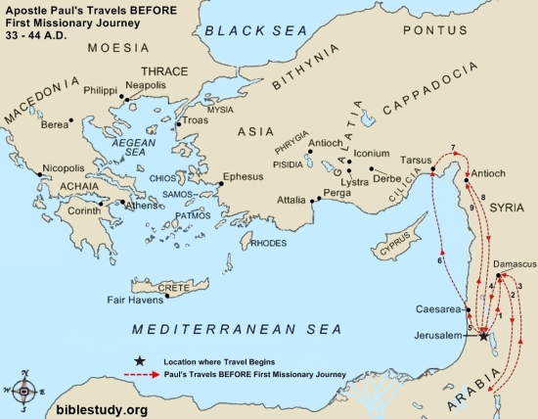
THE APOSTLE PAUL’S JOURNEYS AFTER HIS CONVERION AND BEFORE HIS THREE (3) MISSIONARY JOURNEYS.

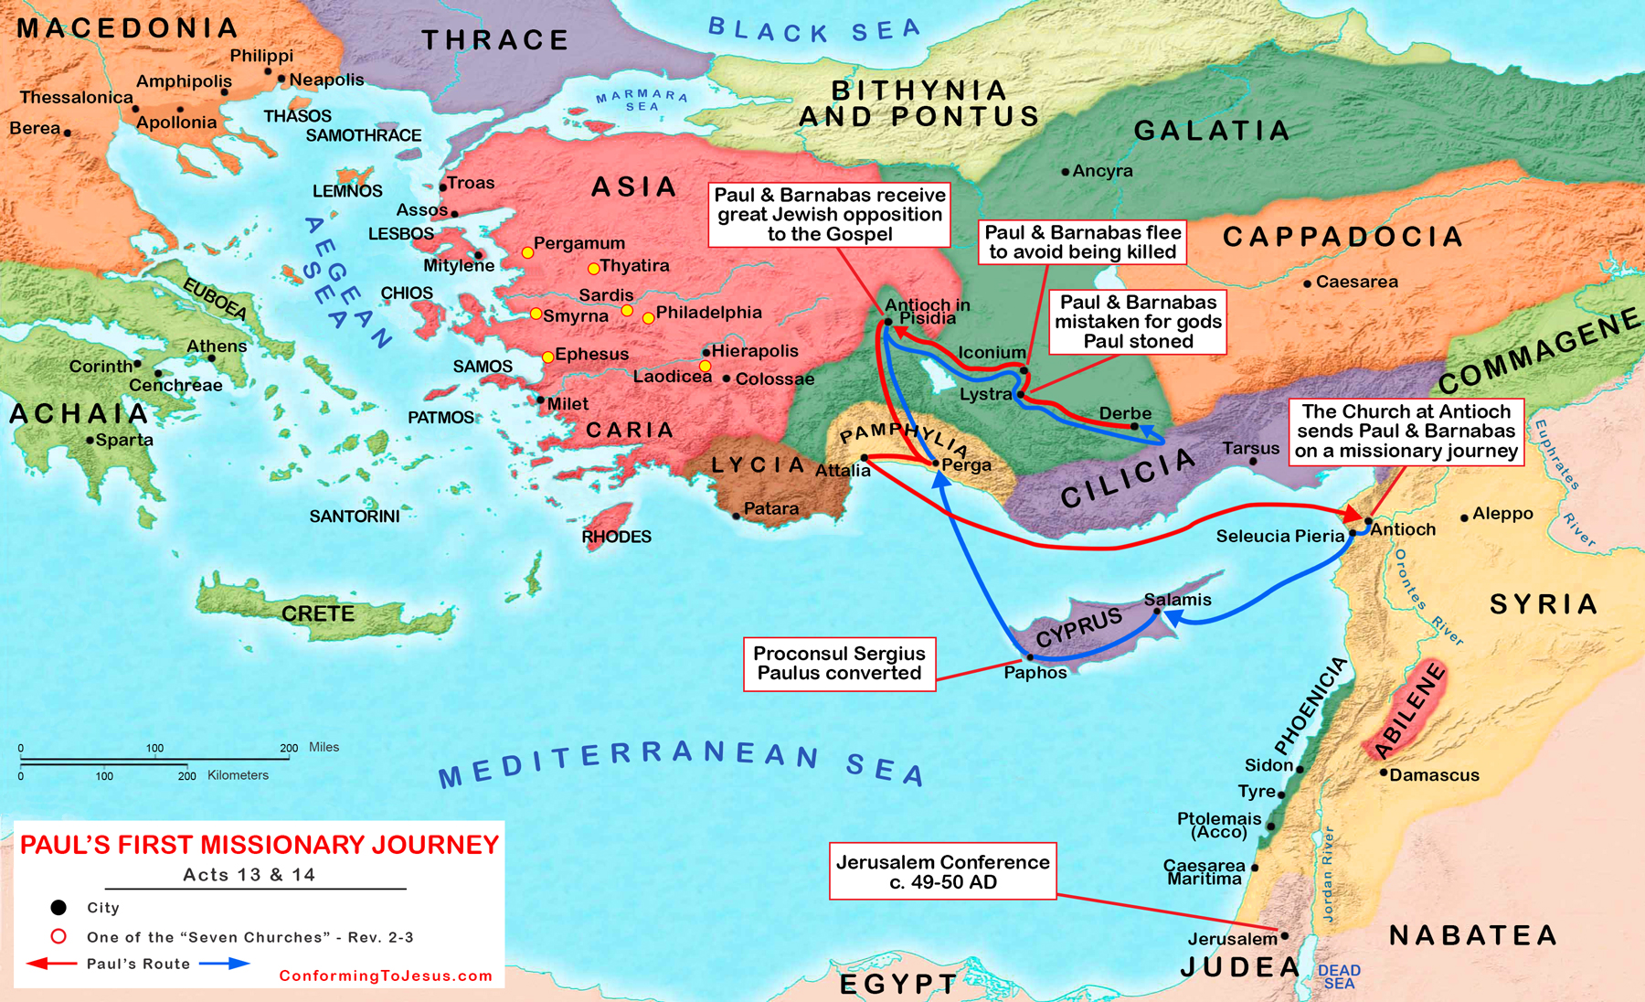
THE APOSTLE PAUL FIRST MISSIONARY JOURNEY

THE APOSTLE PAUL ON HIS SECOND MISSIONARY JOURNEY WENT FROM BEREA TO NICOPOLIS NOT SEEN ON THIS MAP.
THE APOSTLE PAUL WROTE THE EPISTLE TO TITUS FROM
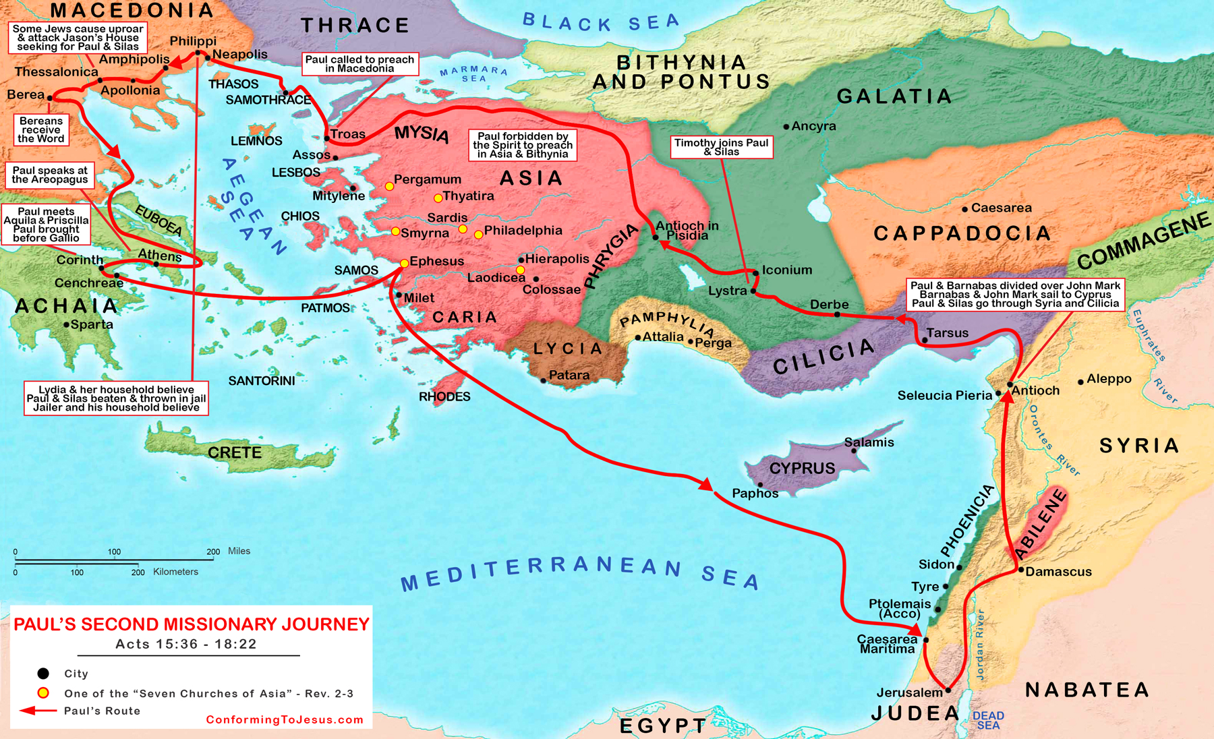
CITY OF NICOPOLIS BY THE SEAS (ACTS 17:14) IN MACEDONIA ON HIS SECOND MISSIONARY JOURNEY.

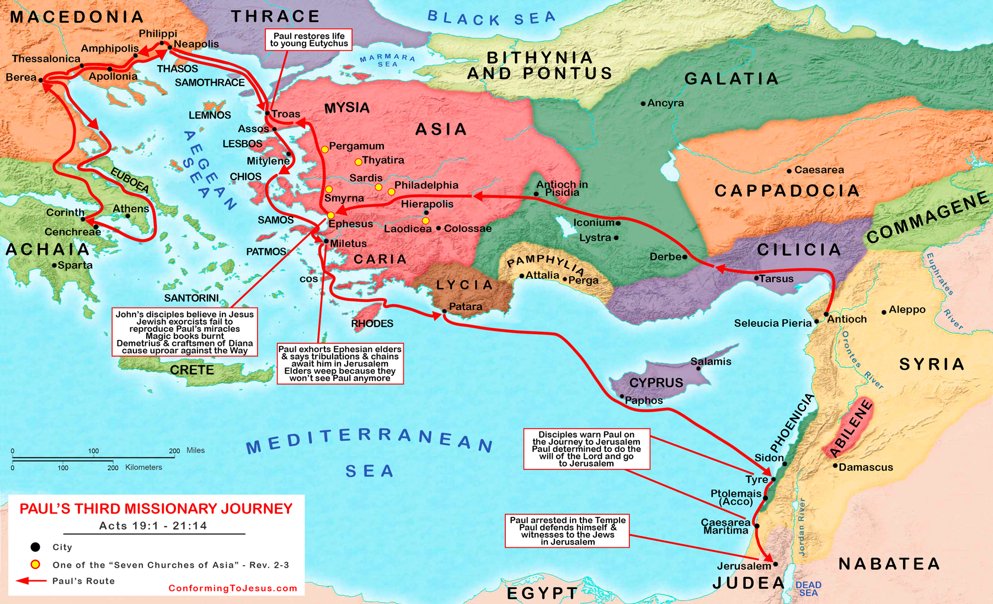
THE APOSTLE PAUL THIRD MISSIONARY JOURNEY

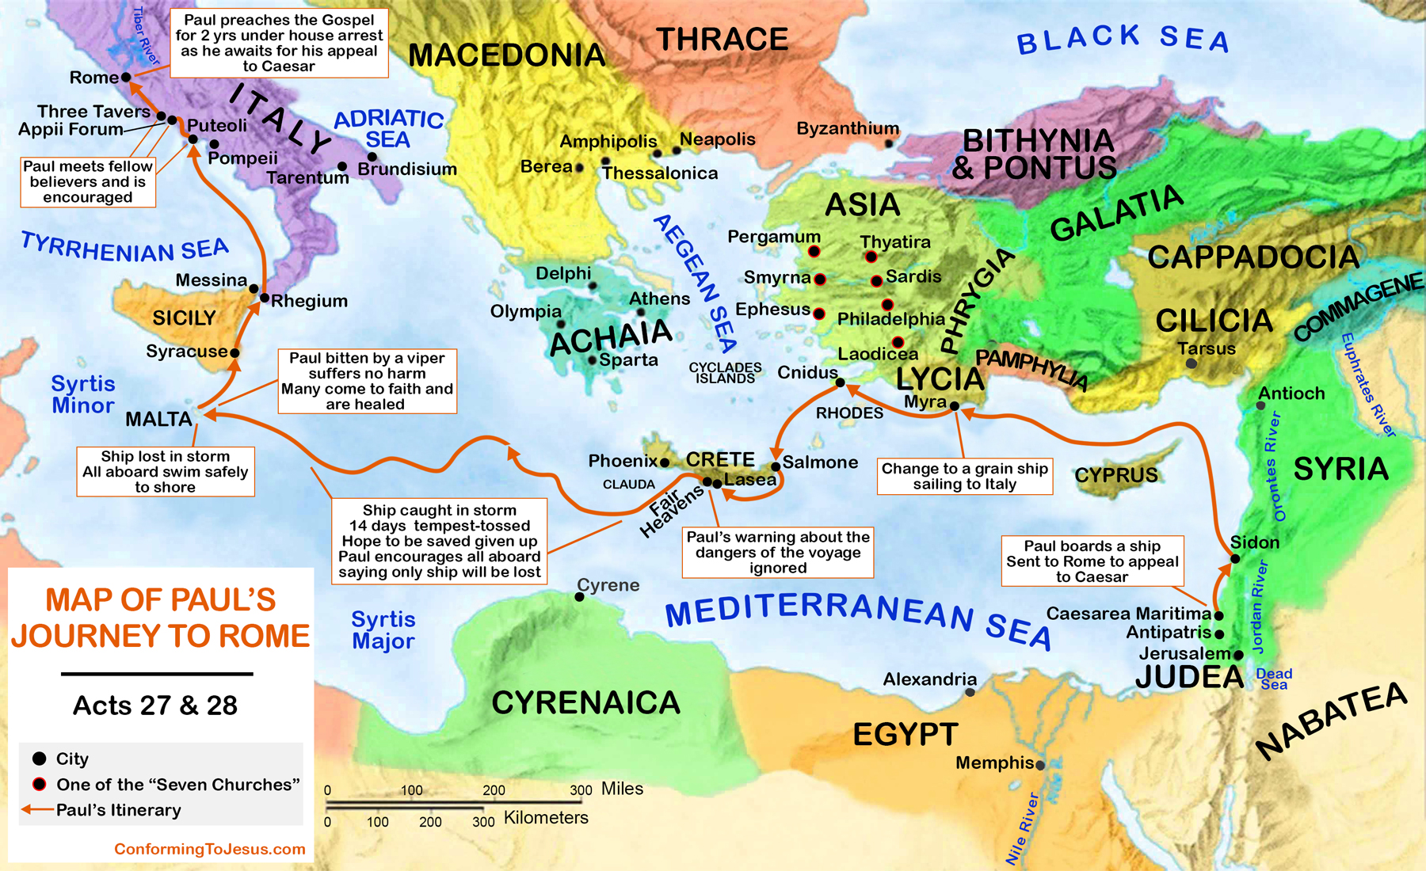
THE APOSTLE PAUL FINAL JOURNEY AS A PRISONER TO ROME, ITALY.

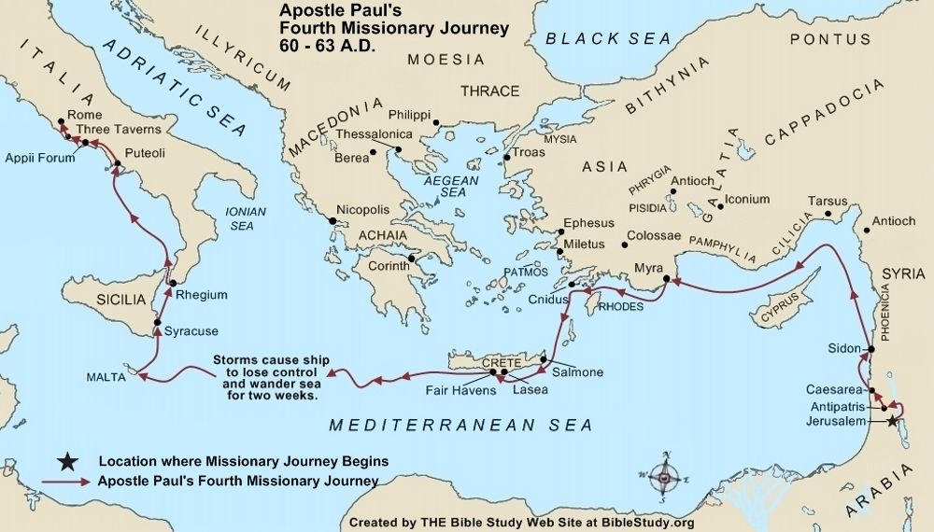
THE APOSTLE PAUL FINAL JOURNEY AS A PRISONER TO ROME, ITALY.

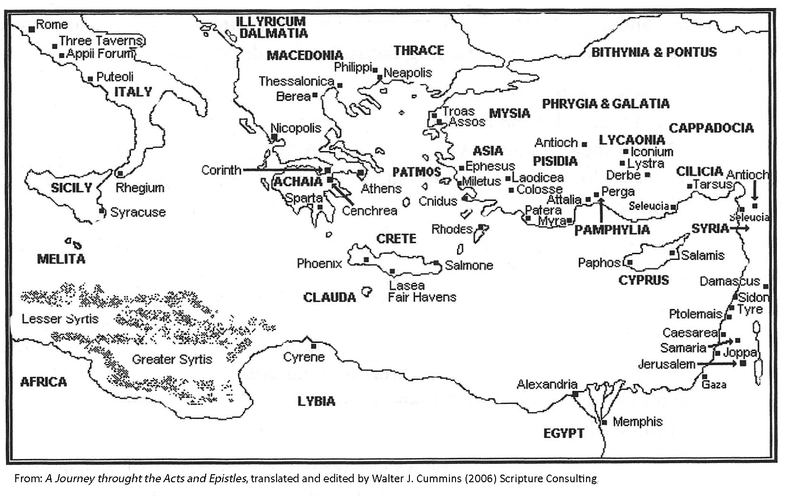
THE MAP OF CRETE WHERE THE APOSTLE PAUL WOULD HAVE STOPPED AND MET BRETHREN ON HIS FINAL JOURNEY AS A PRISONER TO ROME.

